# CHAPTER 1

# INTRODUCTION

A job searching portal is an online platform that connects job seekers with potential employers. It offers a streamlined process for finding employment opportunities, allowing users to search for jobs by location, industry, and job title. Job seekers can upload their resumes, apply for positions, and receive job alerts. Employers, on the other hand, can post job listings, search for qualified candidates, and manage applications. These portals often provide additional resources, such as career advice, resume-building tools, and interview tips, making them valuable tools for both job seekers and employers in the recruitment process.

## PROBLEM STATEMENT

The problem is the inefficiency in connecting job seekers with suitable employment opportunities and employers with qualified candidates. Traditional methods are time-consuming and fragmented, leading to missed opportunities and mismatched placements. A streamlined, user-friendly online job searching portal is needed to address these issues effectively.

## OVERVIEW

A job searching portal is an efficient online platform designed to bridge the gap between job seekers and employers. It simplifies the job search process by offering features like job listings, resume uploads, application management, and job alerts. Employers can post vacancies, search for candidates, and manage applications.

## OBJECTIVE

## The objective of a job searching portal is to revolutionize the employment landscape by creating an integrated platform that bridges the gap between job seekers and employers. This portal is designed to streamline the entire job search and recruitment process, making it more efficient, user-friendly, and effective. For job seekers, the portal offers an intuitive interface that simplifies the search for relevant opportunities through advanced filtering options, personalized job recommendations, and real-time updates on new postings. This not only saves time but also enhances the quality of matches between candidates and available roles.

## For employers, the portal provides powerful tools to manage job listings, screen applications, and identify top talent. By centralizing these functions, employers can reduce the time and effort required to fill positions, ultimately decreasing time-to-hire and improving the quality of hires. Additionally, the portal offers valuable career resources such as resume-building tools, interview preparation guides, and access to online courses, empowering job seekers to enhance their skills and increase their employability.

## Overall, the objective is to create a seamless, efficient, and user-centric platform that supports both job seekers and employers in achieving their goals, while also contributing to the overall improvement of the job market.

# 

# CHAPTER 2

# SYSTEM SPECIFICATION

In this chapter, we are going to see the software that we have used to build the website. This chapter gives you a small description about the software used in the project.

## VS CODE

Visual Studio Code is a source code editor developed by Microsoft for Windows, Linux, and macOS. It includes support for debugging, embedded Git control, syntax highlighting, intelligent code completion, snippets, and code refactoring.

VS Code is an excellent code editor for React projects. It is lightweight, customizable, and has a wide range of features that make it ideal for React development. It also has a built-in terminal for running tasks. Additionally, VS Code has an extensive library of extensions that allow developers to quickly add features like code snippets, debugging tools, and linting support to their projects.

## LOCAL STORAGE

Local storage is a web storage mechanism that allows websites to store data on a user's computer, providing a more secure and efficient alternative to cookies. This data remains accessible even if the user closes the browser or navigates away, enhancing performance by reducing server requests. Local storage is supported by all modern browsers and offers reliability and speed since data is stored locally, unaffected by network issues. It is also secure, as the stored data is only accessible to the user, making it suitable for sensitive information

# CHAPTER 3

# PROPOSED SYSTEM

This chapter gives a small description about the proposed idea behind the development of our website

## PROPOSED SYSTEM

The proposed job searching portal is a user-friendly platform designed to streamline the recruitment process for both job seekers and employers. Job seekers benefit from advanced search filters, a resume builder, application tracking, and job alerts. Employers have access to a comprehensive dashboard for managing job postings, reviewing applications, and finding suitable candidates, with tools to enhance recruitment workflows and communication. The portal also offers valuable career resources, including resume tips and interview guides, aiming to improve job matching efficiency, reduce time-to-hire, and support career development.

## ADVANTAGES

# The job searching portal enhances recruitment with efficient job matching through advanced filters and algorithms, streamlining the application process with features like resume builders and tracking. It offers an intuitive user experience, timely job alerts, and comprehensive employer tools for managing postings and applications. Additionally, it provides valuable career resources such as resume tips and interview guides, reducing time-to-hire and improving overall job search and recruitment efficiency.

# CHAPTER 4 METHODOLOGIES

This chapter gives a small description about how our system works.

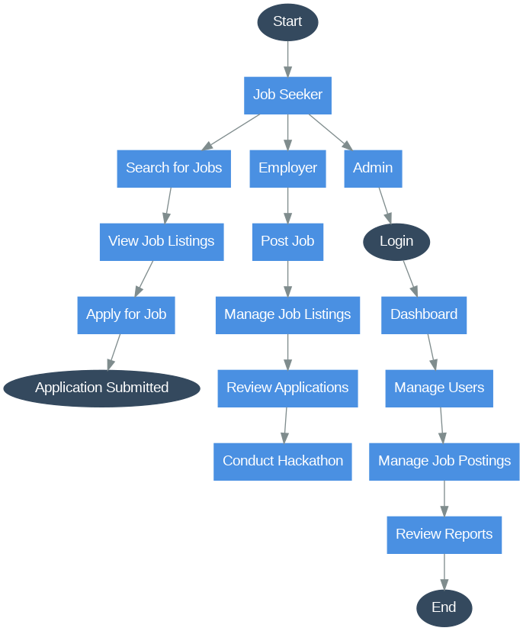

Fig 4.1.Process flow diagram

## USECASE DIAGRAM

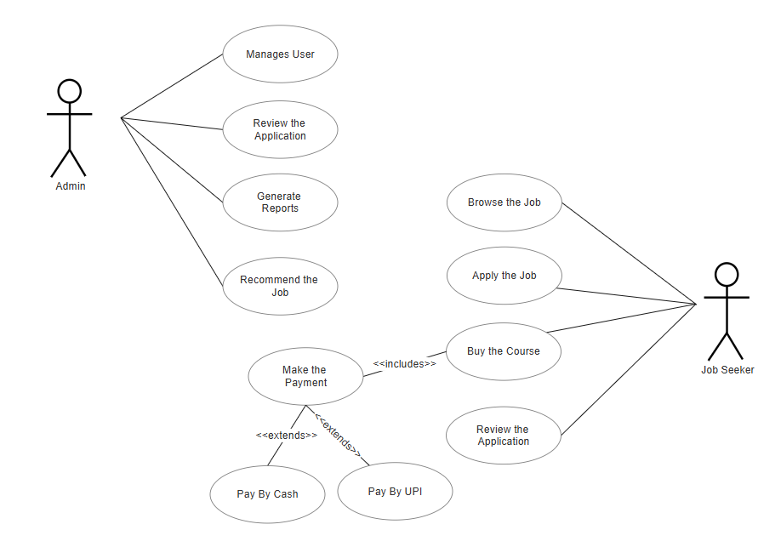

Fig 4.2 Use Case Diagram

**CLASS DIAGRAM**

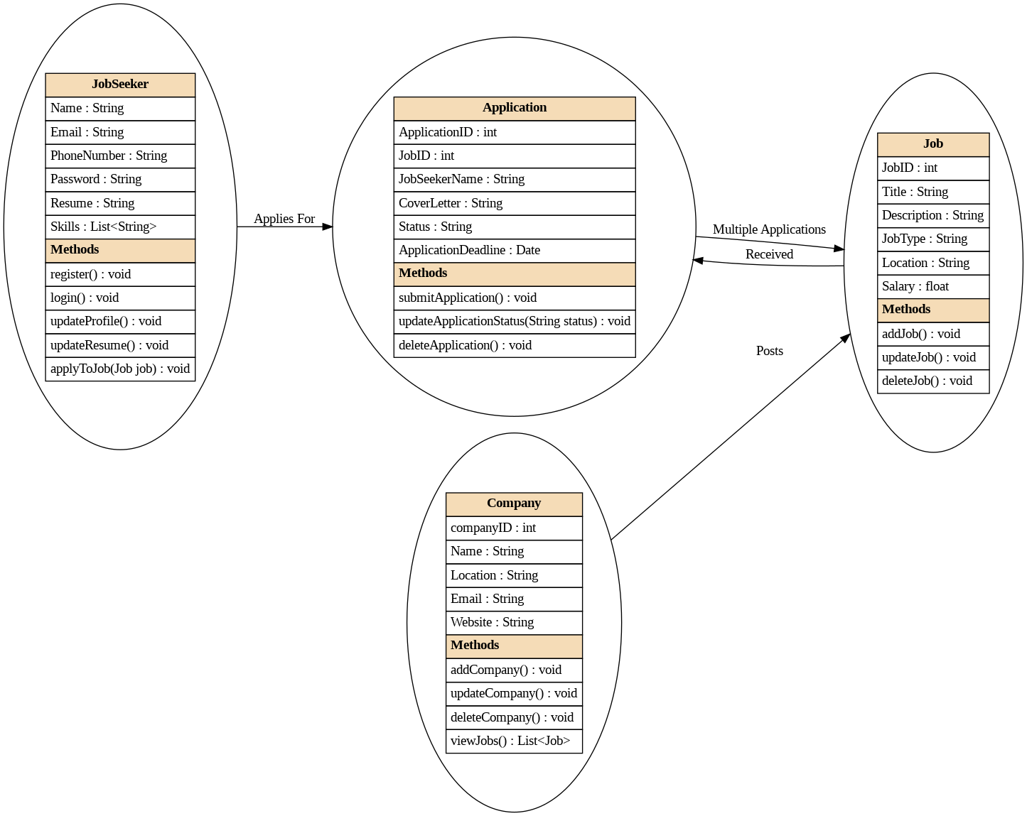

Fig 4.3 Class Diagram

**CHAPTER 5**

**IMPLEMENTATION AND RESULT**

This chapter gives a description about the output that we produced by developing the website of our idea.

## LOGIN AND REGISTER

When User enters our website, the user will be asked about the login details like email id and password. The login details will be verified with the details given while the user creates an account.

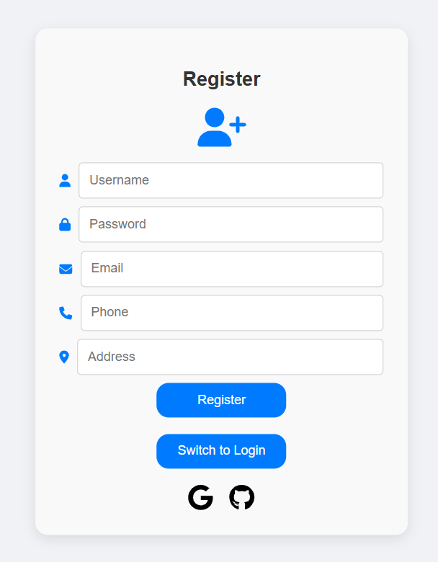

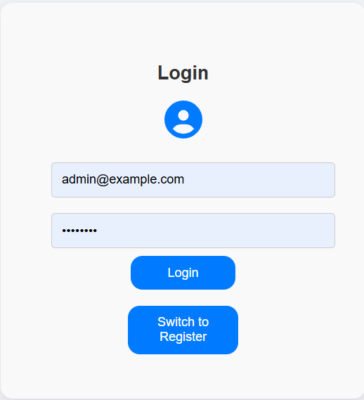

Fig. 5.1.1-2 Employe Login & Register

## 5.2 HOMEPAGE

## ShigoTo is your gateway to career opportunities, designed to connect talented professionals with top employers. Our platform streamlines the job search process, offering tailored job recommendations and advanced search tools to help you find your next career move efficiently.

## 

Fig. 5.2.1 Home Page

## 5.3 JOBLISTS

## The Job List section provides a comprehensive view of available job opportunities, allowing users to search, filter, and sort listings based on their preferences. It features job titles, companies, and locations with interactive elements for a streamlined application process.

## 

## 

## 

## Fig. 5.3.1-2 Job Lists

**5.4 COURSES**

The Courses section offers detailed information on various courses designed to enhance skills and advance careers. It includes course descriptions, instructors, and enrollment options, with filters to help users find relevant learning opportunities**.**

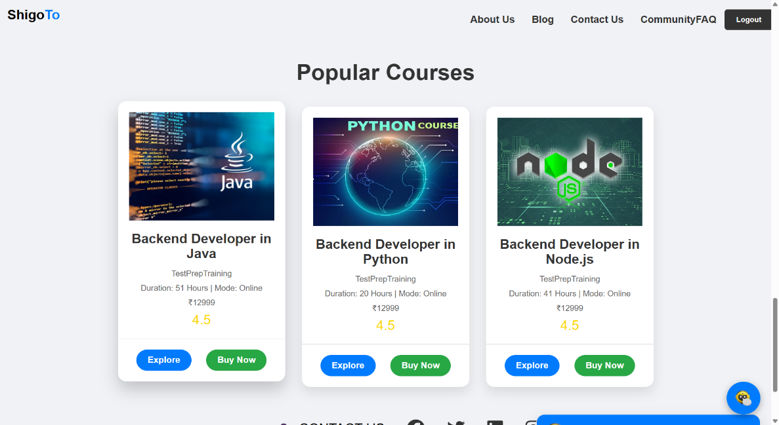

Fig. 5.4.1 Course List

**5.5 ABOUT US**

The About Us section introduces the organization or team behind the portal, outlining their mission, vision, and values. It features team member profiles and highlights their impact and contributions in the field

## 

## 

## 

## 

## Fig. 5.5.1 About Us

## 5.6 CONTACT US

## The Contact section provides users with various ways to reach out for support, inquiries, or feedback. It includes a contact form, email addresses, phone numbers, and office locations. Additionally, it may feature social media links for direct engagement and updates

## 

## Fig. 5.6.1 Contact Us

## 5.7 COMMUNITY FAQ

## The FAQ section addresses common inquiries and issues, providing clear answers to questions related to job applications, course enrollments, and site navigation to enhance user experience.

## 

## 

## 

## Fig. 5.7.1 Community FAQ

## 

## 5.8 JOB APPLICATION FORM

## 

## The Job Application Form allows users to apply for job positions directly through the portal. It collects essential information such as personal details, resume uploads, and cover letters, facilitating a smooth application process for both candidates and employers.

## Fig. 5.8.1 Job Application Form

## 5.9 FOOTER

## 

## The Footer provides essential links such as contact details, social media, privacy policy, and a site map for easy user access

## 

## 

## Fig. 5.9.1 Footer

## 5.10 ADMIN LOGIN

## The Admin Login page is the secure entry point for administrators, providing access to the backend system. It requires authorized credentials and directs users to the admin dashboard upon successful authentication, ensuring that only verified personnel can manage the platform.

## 

## Fig 5.10.1 Login Page

## 5.11 ADMIN DASHBOARD

## The Dashboard offers a centralized overview of key metrics and activities, allowing administrators to monitor platform performance and manage operations efficiently.

## Fig 5.11.1 Dashboard

## 5.12 ADMIN JOB POSTING

## The Job Posting feature enables administrators to create, update, and manage job listings, ensuring that new opportunities are easily accessible to users.

## 

## Fig 5.12.1 Job Posting

## 5.13 ADMIN APPLICATION REVIEW

## The Review Applications functionality allows administrators to evaluate, manage, and track job applications, facilitating a streamlined recruitment process

## 

## Fig 5.13.1 Application

## 5.14 ADMIN CLIENT MANAGEMENT

## The Manage Clients section provides tools to handle client information, maintain relationships, and oversee client-related activities within the platform.

## 

## Fig 5.14.1 Client Management

## 5.15 ADMIN NEWS UPDATES

## The Update News feature allows administrators to publish, edit, and manage news updates, keeping users informed about the latest developments and announcements.

## 

## Fig 5.15.1 News Updates

## 5.16 ADMIN FEEDBACK

## The Feedback feature enables administrators to gather, review, and respond to user feedback, ensuring continuous improvement and user satisfaction.

## 

## Fig 5.16.1 Feedback

## CODING

### LOGIN PAGE

### *function* Login({ *onLogin*, *switchToRegister* }) {

### *const* [username, setUsername] = useState('');

### *const* [password, setPassword] = useState('');

### *const* handleSubmit = async (*e*) *=>* {

### *e*.preventDefault();

### *const* response = await fetch('http://localhost:8080/api/users/login', {

### method: 'POST',

### headers: {

### 'Content-Type': 'application/json'

### },

### body: JSON.stringify({ username, password })

### });

### if (response.ok) {

### onLogin(username, password);

### } else {

### alert('Invalid username or password');

### }

### };

### return (

### <div className="login-form-container">

### <h2>Login</h2>

### <*FontAwesomeIcon* icon={faUserCircle} className="user-icon" />

### <form onSubmit={handleSubmit}>

### <input

### type="text"

### placeholder="Username"

### value={username}

### onChange={(*e*) *=>* setUsername(*e*.target.value)}

### required

### />

### <input

### type="password"

### placeholder="Password"

### value={password}

### onChange={(*e*) *=>* setPassword(*e*.target.value)}

### required

### />

### <center><button type="submit">Login</button></center>

### </form>

### 

### <button className="switch-button" onClick={*switchToRegister*}>Switch to Register</button>

### </div>

### );

### }

### export default Login;

### REGISTRATION PAGE

### *function* Registration({ *onRegister*, *switchToLogin* }) {

### *const* [username, setUsername] = useState('');

### *const* [password, setPassword] = useState('');

### *const* [email, setEmail] = useState('');

### *const* [phone, setPhone] = useState('');

### *const* [address, setAddress] = useState('');

### *const* handleSubmit = async (*e*) *=>* {

### *e*.preventDefault();

### // Store user data in localStorage

### localStorage.setItem('username', username);

### localStorage.setItem('password', password);

### localStorage.setItem('email', email);

### localStorage.setItem('phone', phone);

### localStorage.setItem('address', address);

### // You can also send this data to the backend if needed

### *const* response = await fetch('http://localhost:8080/api/users/register', {

### method: 'POST',

### headers: {

### 'Content-Type': 'application/json'

### },

### body: JSON.stringify({ username, password, email, phone, address

### })

### });

### if (response.ok) {

### onRegister(username, password, email, phone, address);

### } else {

### alert('Failed to register');

### }

### };

### *const* handleGoogleSignIn = () *=>* {

### window.open('https://accounts.google.com/signin', '_blank');

### };

### *const* handleGithubSignIn = () *=>* {

### window.open('https://github.com/login', '_blank');

### };

### return (

### <div className="registration-form-container">

### <h2>Register</h2>

### <*FontAwesomeIcon* icon={faUserPlus} className="user-icon" />

### <form onSubmit={handleSubmit}>

### <div className="input-container">

### <*FontAwesomeIcon* icon={faUser} className="input-icon" />

### <input

### type="text"

### placeholder="Username"

### value={username}

### onChange={(*e*) *=>* setUsername(*e*.target.value)}

### required

### />

### </div>

### <div className="input-container">

### <*FontAwesomeIcon* icon={faLock} className="input-icon" />

### <input

### type="password"

### placeholder="Password"

### value={password}

### onChange={(*e*) *=>* setPassword(e.target.value)}

### required

### />

### </div>

### <div className="input-container">

### <*FontAwesomeIcon* icon={faEnvelope} className="input-icon" />

### <input

### type="email"

### placeholder="Email"

### value={email}

### onChange={(*e*) *=>* setEmail(e.target.value)}

### required

### />

### </div>

### <div className="input-container">

### <*FontAwesomeIcon* icon={faPhone} className="input-icon" />

### <input

### type="tel"

### placeholder="Phone"

### value={phone}

### onChange={(*e*) *=>* setPhone(*e*.target.value)}

### required

### />

### </div>

### <div className="input-container">

### <*FontAwesomeIcon* icon={faMapMarkerAlt} className="input-icon" />

### <input

### type="text"

### placeholder="Address"

### value={address}

### onChange={(*e*) *=>* setAddress(*e*.target.value)}

### required

### />

### </div>

### <center><button type="submit">Register</button></center>

### </form>

### <button className="switch-button" onClick={*switchToLogin*}>Switch to Login</button>

### <div className="social-signin">

### <*FontAwesomeIcon* icon={faGoogle} className="social-icon" onClick={handleGoogleSignIn} />

### <*FontAwesomeIcon* icon={faGithub} className="social-icon" onClick={handleGithubSignIn} />

### </div>

### </div>

### );

### }

### export default Registration;

### HOMEPAGE

### *const* districts = [

### 'Coimbatore',

### 'Chennai',

### 

### 'Salem',

### 'Nammakal',

### 'Trichy',

### // Add more districts as needed

### ];

### *const* Welcome = () *=>* {

### *const* [timer, setTimer] = useState(10);

### *const* [intervalId, setIntervalId] = useState(null);

### *const* handleLogout = () *=>* {

### *const* id = setInterval(() *=>* {

### setTimer(*prevTimer* *=>* {

### if (*prevTimer* <= 1) {

### clearInterval(id);

### setTimer(0);

### } else {

### return *prevTimer* - 1;

### }

### });

### }, 1000);

### setIntervalId(id);

### toast.info(

### <div>

### <p>Are you sure you want to logout?</p>

### <p>Time remaining: {timer} seconds</p>

### <div className="toast-button-container">

### <button

### onClick={() *=>* {

### clearInterval(id);

### toast.success('Logged out successfully');

### setTimeout(() *=>* {

### window.location.href = '/login';

### }, 1000);

### }}

### className="toast-button toast-button-yes"

### >

### Yes

### </button>

### <button

### onClick={() *=>* {

### 

### clearInterval(id);

### toast.error('Logout canceled');

### }}

### className="toast-button toast-button-no"

### >

### No

### </button>

### </div>

### </div>,

### {

### autoClose: false,

### closeOnClick: false,

### draggable: false,

### onClose: () *=>* {

### clearInterval(intervalId);

### },

### }

### );

### };

### useEffect(() *=>* {

### return () *=>* {

### clearInterval(intervalId);

### };

### }, [intervalId]);

### *const* [isScrolled, setIsScrolled] = useState(false);

### useEffect(() *=>* {

### *const* handleScroll = () *=>* {

### if (window.scrollY > 0) {

### setIsScrolled(true);

### } else {

### setIsScrolled(false);

### }

### };

### window.addEventListener('scroll', handleScroll);

### return () *=>* {

### window.removeEventListener('scroll', handleScroll);

### };

### }, []);

### return (

### <div className="welcome-page">

### <header className={`header ${isScrolled ? 'scrolled' : ''}`}>

### <div className="logo"><span className='logoo'>Shigo</span><span className='logoo1'>To</span></div>

### <nav className="nav">

### {/* <a href="/home">Home</a> */}

### <a href="/about">About Us</a>

### <a href="/blog">Blog</a>

### <a href="/contactus">Contact Us</a>

### <a href="/communityfaq">CommunityFAQ</a>

### <button className="logout-button" onClick={handleLogout}>Logout</button>

### </nav>

### </header>

### <div className="main-content">

### <div className="text-content">

### <h1>Craft Your Future Success...</h1>

### <p>Explore Career Paths, Network with Visionaries</p>

### </div>

### <div className="search-bar">

### <div className="search-input-group">

### <*MdWork* className="search-icon" />

### <select className="search-select">

### <option value="">Job Role</option>

### <option value="developer">Developer</option>

### <option value="designer">Designer</option>

### <option value="manager">Manager</option>

### {/* Add more roles as needed */}

### </select>

### </div>

### <div className="search-input-group">

### <*MdWorkOutline* className="search-icon" />

### <select className="search-select">

### <option value="">Job Type</option>

### <option value="full-time">Full-Time</option>

### <option value="part-time">Part-Time</option>

### <option value="internship">Internship</option>

### {/* Add more types as needed */}

### </select>

### </div>

### <div className="search-input-group">

### <*CiLocationOn* className="search-icon" />

### <select className="search-select">

### <option value="">Location</option>

### {districts.map((*district*, *index*) *=>* (

### <option key={*index*} value={*district*}>{*district*}</option>

### ))}

### </select>

### </div>

### <div className="search-input-group">

### <*BsFillCalendarCheckFill* className="search-icon" />

### <select className="search-select">

### <option value="">Experience Level</option>

### <option value="junior">Junior</option>

### <option value="mid">Mid-Level</option>

### <option value="senior">Senior</option>

### {/* Add more levels as needed */}

### </select>

### </div>

### <button className="search-button">

### <*AiOutlineSearch* className="search-button-icon" />

### Search

### </button>

### </div>

### <div>

### <*TopHiringCompanies* />

### </div>

### <div className="content">

### {/* <Sidebar /> */}

### <*RemoteJobs* />

### </div>

### <div className='context1'>

### <*WalkinJobs* />

### </div>

### <div className='context2'>

### <*DomainJobs* />

### </div>

### <div className='context5'>

### <*Recuriter* />

### </div>

### 

### <div>

### <*JobCard* />

### </div>

### 

### <div className="footer">

### 

### <*Footer* />

### </div>

### </div>

### <div>

### <*Chatbot* />

### </div>

### <*ToastContainer* />

### </div>

### );

### };

### export default Welcome;

### ADMIN DASHBOARD

### *const* Dashboard = () *=>* {

### *const* [data, setData] = useState(() *=>* {

### *const* savedData = localStorage.getItem('dashboardData');

### return savedData ? JSON.parse(savedData) : {}; // Initialize with an empty object if no data

### });

### *const* [news, setNews] = useState(() *=>* {

### *const* savedNews = localStorage.getItem('news');

### return savedNews ? JSON.parse(savedNews) : []; // Initialize with an empty array if no data

### });

### *const* [registrationDetails, setRegistrationDetails] = useState({

### username: '',

### email: '',

### phone: '',

### address: '',

### });

### 

### useEffect(() *=>* {

### // Simulate live data updates every 5 seconds

### *const* interval = setInterval(() *=>* {

### 

### setData(*prevData* *=>* {

### *const* updatedData = {

### ...*prevData*,

### jobsPosted: *prevData*.jobsPosted?.map(*item* *=>* ({

### ...*item*,

### jobsPosted: *item*.jobsPosted + Math.floor(Math.random() * 10),

### })) || [],

### applications: *prevData*.applications?.map(*item* *=>* ({

### ...*item*,

### applications: *item*.applications + Math.floor(Math.random() * 50),

### })) || [],

### activeUsers: *prevData*.activeUsers + Math.floor(Math.random() * 10), // Update active users

### revenue: *prevData*.revenue + Math.floor(Math.random() * 5000), // Update revenue

### };

### localStorage.setItem('dashboardData', JSON.stringify(updatedData));

### return updatedData;

### });

### }, 5000); // Update every 5 seconds

### return () *=>* clearInterval(interval);

### }, []);

### useEffect(() *=>* {

### // Fetch registration details from localStorage

### *const* username = localStorage.getItem('username');

### *const* email = localStorage.getItem('email');

### *const* phone = localStorage.getItem('phone');

### *const* address = localStorage.getItem('address');

### setRegistrationDetails({

### username: username || 'N/A',

### email: email || 'N/A',

### phone: phone || 'N/A',

### address: address || 'N/A',

### });

### }, []);

### useEffect(() *=>* {

### 

### // Retrieve news from localStorage when the component mounts

### *const* savedNews = localStorage.getItem('news');

### if (savedNews) {

### setNews(JSON.parse(savedNews));

### }

### }, []);

### *const* totalJobsPosted = data.jobsPosted?.reduce((*sum*, *item*) *=>* *sum* + *item*.jobsPosted, 0) || 0;

### *const* totalApplications = data.applications?.reduce((*sum*, *item*) *=>* *sum* + *item*.applications, 0) || 0;

### return (

### <div className="dashboard-container">

### <*Sidebar* />

### <div className="dashboard-content">

### <header className="dashboard-header">

### <h1>Admin Dashboard</h1>

### </header>

### <div className="dashboard-metrics">

### <div className="metric-card">

### <h3>Total Jobs Posted</h3>

### <p>{totalJobsPosted}</p>

### </div>

### <div className="metric-card">

### <h3>Total Applications</h3>

### <p>{totalApplications}</p>

### </div>

### <div className="metric-card">

### <h3>Revenue</h3>

### <p><*FaDollarSign* /> {data.revenue?.toLocaleString() || '0'}</p>

### </div>

### <div className="metric-card">

### <h3>Active Users</h3>

### <p><*FaUserAlt* /> {data.activeUsers || '0'}</p>

### </div>

### </div>

### <div className="dashboard-charts">

### 

### <div className="chart-container">

### <h3>Jobs Posted Overview</h3>

### <*ResponsiveContainer* width="100%" height={250}>

### <*BarChart* data={data.jobsPosted || []}>

### <*CartesianGrid* strokeDasharray="3 3" />

### <*XAxis* dataKey="name" />

### <*YAxis* />

### <*Tooltip* />

### <*Legend* />

### <*Bar* dataKey="jobsPosted" fill="#8884d8" />

### </*BarChart*>

### </*ResponsiveContainer*>

### </div>

### <div className="chart-container">

### <h3>Applications Overview</h3>

### <*ResponsiveContainer* width="100%" height={250}>

### <*LineChart* data={data.applications || []}>

### <*CartesianGrid* strokeDasharray="3 3" />

### <*XAxis* dataKey="name" />

### <*YAxis* />

### <*Tooltip* />

### <*Legend* />

### <*Line* type="monotone" dataKey="applications" stroke="#82ca9d" />

### </*LineChart*>

### </*ResponsiveContainer*>

### </div>

### <div className="chart-container">

### <h3>Job Categories Distribution</h3>

### <*ResponsiveContainer* width="100%" height={250}>

### <*PieChart*>

### <*Pie* data={data.jobCategories || []} dataKey="jobs" nameKey="name" fill="#8884d8" />

### <*Tooltip* />

### <*Legend* />

### </*PieChart*>

### </*ResponsiveContainer*>

### </div>

### </div>

### <div className="dashboard-upcoming-events">

### <h3>Upcoming Events</h3>

### <ul>

### {data.upcomingEvents?.map((*event*, *index*) *=>* (

### <li key={*index*}>

### 

### <*FaCalendarAlt* /> {*event*.date} - {*event*.event}

### </li>

### ))}

### </ul>

### </div>

### <div className="dashboard-news">

### <h3>Recent News</h3>

### <ul>

### {news.length === 0 ? (

### <p>No recent news available.</p>

### ) : (

### news.map((*item*, *index*) *=>* (

### <li key={*index*}>

### <*FaNewspaper* /> {*item*.title} ({*item*.date})

### </li>

### ))

### )}

### </ul>

### </div>

### <div className="dashboard-scheduled-meetings">

### <h3>Scheduled Meetings</h3>

### <ul>

### {data.scheduledMeetings?.map((*meeting*, *index*) *=>* (

### <li key={*index*}>

### <*FaTasks* /> {*meeting*.title} - {*meeting*.date}

### </li>

### ))}

### </ul>

### </div>

### {/* Display registration details */}

### <div className="registration-details">

### <h3>Registered User Details</h3>

### <p><strong>Username:</strong> {registrationDetails.username}</p>

### <p><strong>Email:</strong> {registrationDetails.email}</p>

### <p><strong>Phone:</strong> {registrationDetails.phone}</p>

### <p><strong>Address:</strong> {registrationDetails.address}</p>

### </div>

### <footer className="dashboard-footer">

### 

### <p>&copy; 2024 Your Company. All rights reserved.</p>

### </footer>

### </div>

### </div>

### );

### };

### export default Dashboard;

# CHAPTER 6

# IMPLEMENTATION OF BACKEND

# 6.1 INTRODUCTION

# The backend of the Job Searching Portal is a critical component of the application, responsible for handling data management, user authentication, job postings, and secure communication between the client and server. The backend is built using Spring Boot, a popular Java framework for building microservices and RESTful APIs. This report provides an in-depth analysis of the backend architecture, including configuration, controller services, and security mechanisms.

# 6.2 ARCHITECTURE AND COMPONENTS

# The backend architecture is composed of several key components, including:

# Spring Boot Framework: Utilized for building a robust RESTful API with support for dependency injection, security, and data management.

# MySQL Database: Used as the primary relational database for storing user data, job postings, and other application-related information.

# Spring Security: Provides authentication and authorization functionalities, ensuring secure access to the application's resources.

# JWT (JSON Web Token): Used for user authentication, providing a secure and scalable solution for managing user sessions.

# Service Layer: Handles business logic and interaction between the controllers and repositories.

# Repository Layer: Responsible for data access and persistence, leveraging JPA (Java Persistence API) for database interactions.

# 6.3 COMPONENTS DESCRIPTION

# 6.3.1. CONFIGURATION

# The configuration files define the overall behavior of the backend, including CORS (Cross-Origin Resource Sharing) settings, security configurations, and database connections.

# CorsConfig: Manages CORS settings, allowing the frontend application hosted on http://localhost:3000 to interact with the backend services.

# SecurityConfig: Configures the security settings, permitting public access to specific endpoints such as user registration, login, and job application APIs, while restricting access to other resources.

# 6.3.2 CONTROLLERS

# Controllers are responsible for handling HTTP requests, processing data, and returning appropriate responses.

# AdminController.java: Manages administrative tasks, including job posting approvals and user management.

# ApplicationController.java: Handles operations related to job applications, such as applying for jobs and viewing application status.

# CompanyController.java: Manages company-related operations, including company registration and profile management.

# JobController.java: Manages job postings, allowing users to create, view, update, and delete job listings.

# JobseekerController.java: Handles job seeker operations, including registration, profile updates, and job search functionalities.

# 6.3.3 SERVICES

# The service layer contains business logic and interacts with the repository layer to perform CRUD (Create, Read, Update, Delete) operations.

# AdminService.java: Provides methods for managing administrative functionalities.

# ApplicationService.java: Manages job application processes and interactions with the application repository.

# CompanyService.java: Provides business logic for company-related operations and interactions with the company repository.

# JobSeekerService.java: Manages job seeker-related operations, including profile updates and job searches.

# JobService.java: Provides methods to add, retrieve, update, and delete job postings.

# 6.3.4 MODELS

# The models represent the database entities and are annotated with JPA annotations for ORM (Object-Relational Mapping).

# Admin.java: Represents an admin entity with attributes specific to administrative roles.

# Application.java: Represents a job application entity, including attributes like job seeker ID, job ID, application date, and status.

# Company.java: Represents a company entity, containing attributes such as company name, address, and profile details.

# Job.java: Represents a job posting entity, with attributes like title, description, location, company name, salary range, job type, benefits, and job level.

# JobSeeker.java: Represents a job seeker entity, containing attributes such as username, password, email, phone, and address.

# 6.3.5 REPOSITORIES

# Repositories interface with the database, allowing the application to perform CRUD operations seamlessly.

# AdminRepository.java: Extends JpaRepository to provide data access for admin-related information.

# ApplicationRepository.java: Extends JpaRepository to provide data access for job applications.

# CompanyRepository.java: Extends JpaRepository to provide data access for company information.

# JobRepository.java: Extends JpaRepository to provide data access for job postings.

# JobSeekerRepository.java: Extends JpaRepository to provide data access for job seeker information.

# 6.3.6. SECURITY

# Security is implemented using Spring Security and JWT for authentication.

# BCryptPasswordEncoder: Encrypts user passwords before storing them in the database.

# JwtUtil: Handles JWT generation, extraction of claims, and token validation.

# 

#### 

#### 6.3.6.1 Backend System Architecture

**CHAPTER 7**

**ENTITY RELATIONSHIP**

**7.1 ENTITIES**

**7.1.1 ADMIN**

* id: Long (Primary Key)
* username: String
* password: String
* email: String
* phone: String
* address: String
* role: String

**7.1.2 APPLICATION**

* id: Long (Primary Key)
* jobSeekerId: Long (Foreign Key referencing JobSeeker)
* jobId: Long (Foreign Key referencing Job)
* applicationDate: String
* status: String

**7.1.3 COMPANY**

* id: Long (Primary Key)
* name: String
* address: String
* email: String
* phone: String
* website: String

**7.1.4 JOB**

* id: Long (Primary Key)
* title: String
* description: String
* location: String
* companyName: String
* salaryRange: String
* jobType: String
* benefits: String
* jobLevel: String
* postingDate: String
* companyId: Long (Foreign Key referencing Company)

**7.1.5 JOBSEEKER**

* id: Long (Primary Key)
* username: String
* password: String
* email: String
* phone: String
* address: String
* resume: String

**7.2 IMAGES**

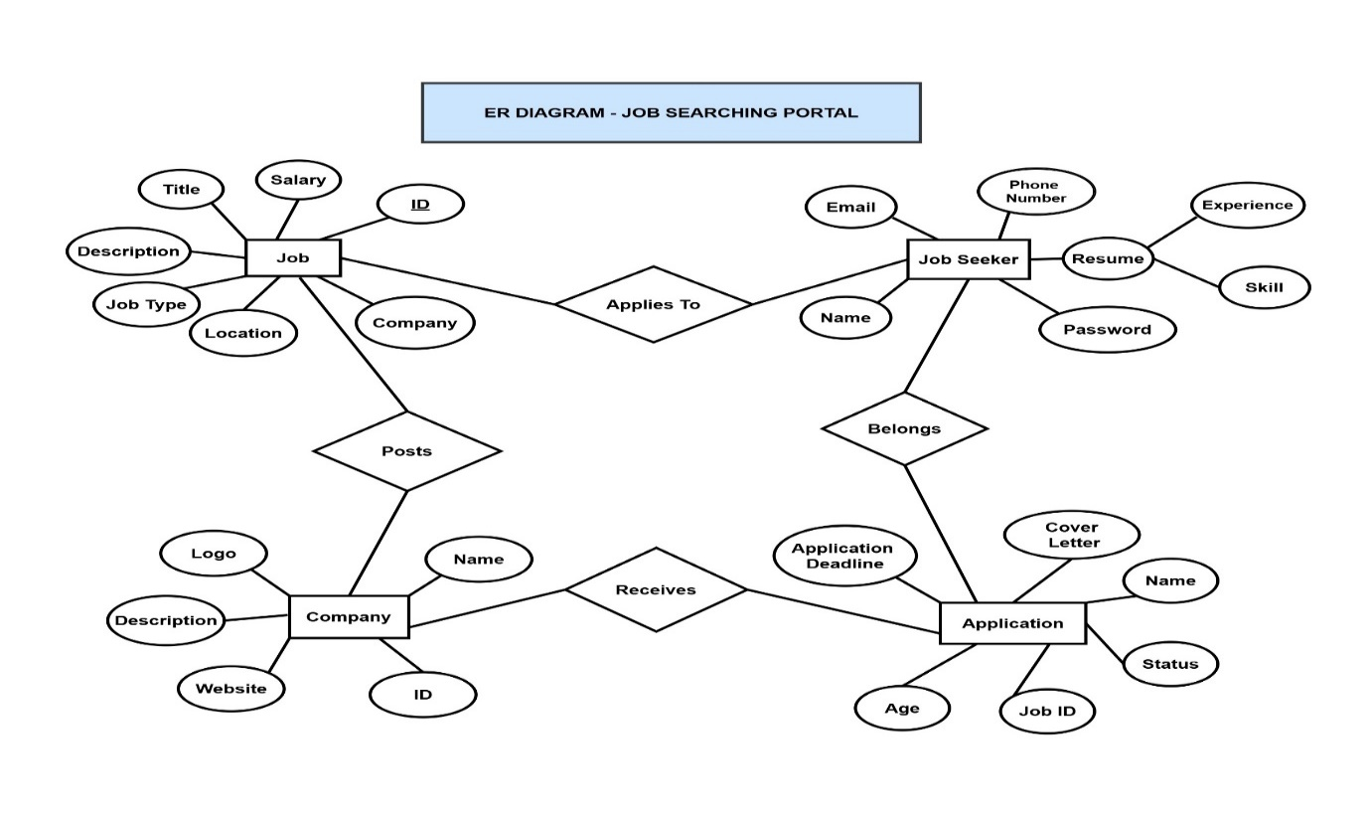**7.2.1. ENTITY DIAGRAM**

Fig-7.2.1 ER-Diagram

**7.2.2 UML COMPONENT DIAGRAM**

Fig-7.2.2. UML Component Diagram

**7.2.3. BACKEND FLOWCHART**

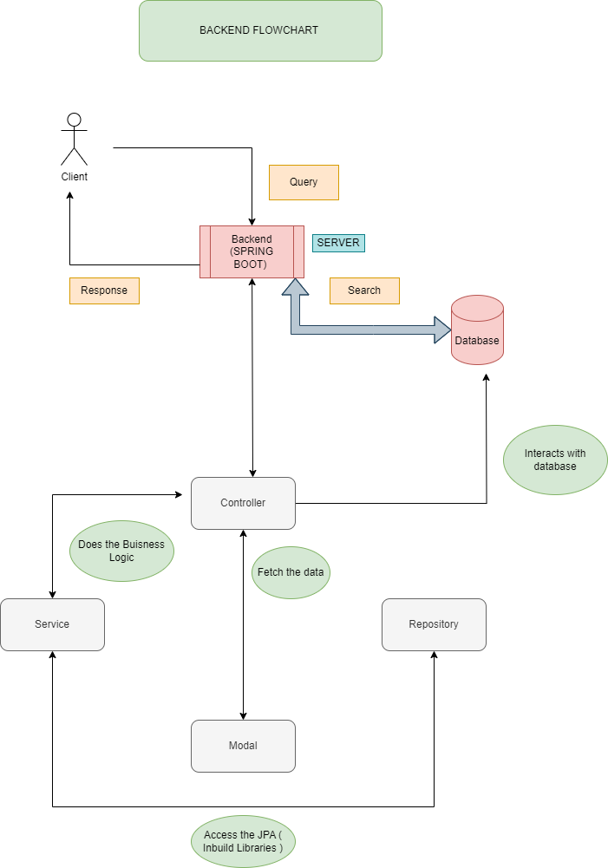

Fig-7.2.3 Backend Flowchart

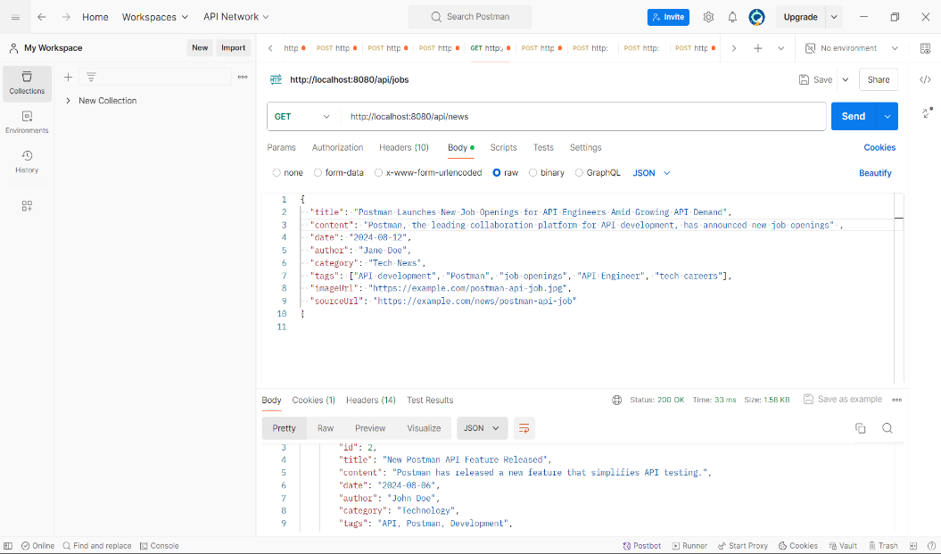**7.2.4. POSTMAN API**

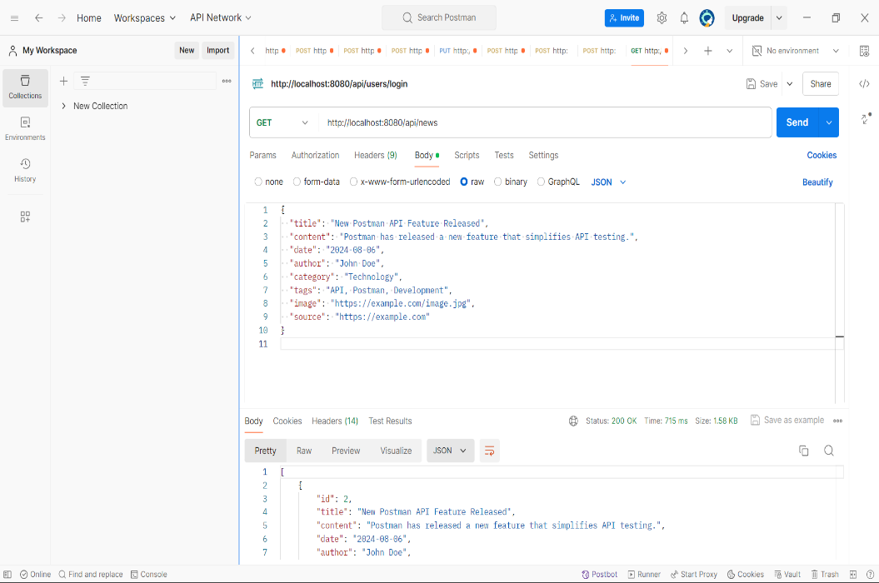

Fig-7.2.4.1-2 Postman Api

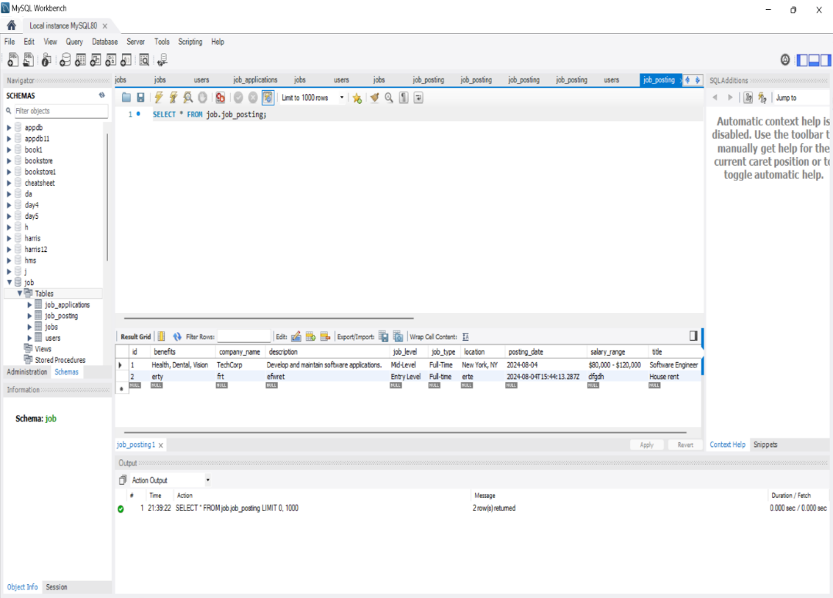**7.2.5. MYSQL DATABASE**

7.2.5 Mysql Database

# 

# 

# CHAPTER 8

# BACKEND CODING

**8.1 USERCONTROLLER.JAVA**

@*RestController*

@*RequestMapping*("/api/users")

@*CrossOrigin*(origins = "http://localhost:3000")// frontend oda localhost

public class UserController {

    @*Autowired*

    private UserService userService;

    @*PostMapping*("/register")

    public ResponseEntity<User> registerUser(@*RequestBody* User *user*) {

        return ResponseEntity.ok(userService.registerUser(*user*));

    }

    @*PostMapping*("/login")

public ResponseEntity<String> loginUser(@*RequestBody* User *loginUser*) {

    String token = userService.loginUser(*loginUser*.getUsername(), *loginUser*.getPassword());

    if (token != null) {

        return ResponseEntity.ok(token);

    } else {

        return ResponseEntity.status(401).build();

    }

}

    @*GetMapping*

    public ResponseEntity<List<User>> getAllUsers() {

        return ResponseEntity.ok(userService.getAllUsers());

    }

    @*GetMapping*("/{id}")

    public ResponseEntity<User> getUserById(@*PathVariable* Long *id*) {

        Optional<User> user = userService.getUserById(*id*);

return user.map(ResponseEntity::ok).orElseGet(() *->* ResponseEntity.notFound().build());

    }

@*PutMapping*("/{id}")

    public ResponseEntity<User> updateUser(@*PathVariable* Long *id*, @*RequestBody* User *user*) {

        Optional<User> updatedUser = userService.updateUser(*id*, *user*);

        return updatedUser.map(ResponseEntity::ok).orElseGet(() *->* ResponseEntity.notFound().build());

    }

    @*DeleteMapping*("/{id}")

    public ResponseEntity<Void> deleteUser(@*PathVariable* Long *id*) {

        if (userService.deleteUser(*id*)) {

            return ResponseEntity.noContent().build();

        } else {

            return ResponseEntity.notFound().build();

        }

    }

}

**8.2 JOBCONTROLLER.JAVA**

@*RestController*

@*RequestMapping*("/api/job")

@*CrossOrigin*(origins = "http://localhost:3000")

public class JobController {

    @*Autowired*

    private JobService jobService;

    @*PostMapping*

    public ResponseEntity<Job> addJob(@*RequestBody* Job *job*) {

        Job newJob = jobService.addJob(*job*);

        return new ResponseEntity<>(newJob, HttpStatus.CREATED);

    }

    @*GetMapping*

    public ResponseEntity<List<Job>> getAllJobs() {

        List<Job> jobs = jobService.getAllJobs();

        return new ResponseEntity<>(jobs, HttpStatus.OK);

    }

    @*DeleteMapping*("/{id}")

    public ResponseEntity<Void> deleteJob(@*PathVariable* Long *id*) {

        jobService.deleteJob(*id*);

        return new ResponseEntity<>(HttpStatus.NO_CONTENT);

    }

}

**8.3 CONTACTCONTROLLER.JAVA**

@*RestController*

@*RequestMapping*("/api/contact")

@*CrossOrigin*(origins = "http://localhost:3000")

public class ContactController {

    @*Autowired*

    private ContactService contactService;

    @*PostMapping*

    public ResponseEntity<String> saveContact(@*RequestBody* Contact *contact*) {

        Contact savedContact = contactService.saveContact(*contact*);

        return ResponseEntity.ok("Contact details saved successfully with ID: " + savedContact.getId());

    }

    @*GetMapping*

    public ResponseEntity<List<Contact>> getAllContacts() {

        List<Contact> contacts = contactService.getAllContacts();

        return ResponseEntity.ok(contacts);

    }

    @*DeleteMapping*("/{id}")

    public ResponseEntity<String> deleteContact(@*PathVariable* Long *id*) {

        contactService.deleteContact(*id*);

        return ResponseEntity.ok("Contact deleted successfully.");

    }

}

**8.4. NEWSCONTROLLER.JAVA**

@*RestController*

@*RequestMapping*("/api/news")

@*CrossOrigin*(origins = "http://localhost:3000") // Adjust based on your React app's URL

public class NewsController {

    @*Autowired*

    private NewsService newsService;

    @*GetMapping*

    public List<News> getAllNews() {

        return newsService.getAllNews();

    }

    @*GetMapping*("/{id}")

    public ResponseEntity<News> getNewsById(@*PathVariable* Long *id*) {

        return newsService.getNewsById(*id*)

                .map(ResponseEntity::ok)

                .orElse(ResponseEntity.notFound().build());

    }

    @*PostMapping*

    public News createNews(@*RequestBody* News *news*) {

        return newsService.addNews(*news*);

    }

    @*PutMapping*("/{id}")

    public ResponseEntity<News> updateNews(@*PathVariable* Long *id*, @*RequestBody* News *newsDetails*) {

        return ResponseEntity.ok(newsService.updateNews(*id*, *newsDetails*));

    }

    @*DeleteMapping*("/{id}")

    public ResponseEntity<Void> deleteNews(@*PathVariable* Long *id*) {

        newsService.deleteNews(*id*);

        return ResponseEntity.noContent().build();

    }

}

**8.5 JWTUTIL.JAVA**

public class JwtUtil {

 private static final String SECRET_KEY = "DWnN2JPlmIimWXd3ZJWJtQ9mQOggGynoZpLCtvrGr/M=";

    private static final *long* EXPIRATION_TIME = 1000 * 60 * 60; // 1 hour expiration time

    public static String generateToken(String *username*) {

        return Jwts.builder()

                .setSubject(*username*)

                .setIssuedAt(new Date())

                .setExpiration(new Date(System.currentTimeMillis() + EXPIRATION_TIME))

                .signWith(SignatureAlgorithm.HS256, SECRET_KEY)

                .compact();

    }

    public static Claims extractClaims(String *token*) {

        return Jwts.parserBuilder()

                .setSigningKey(SECRET_KEY)

                .build()

                .parseClaimsJws(*token*)

                .getBody();

    }

    public static String extractUsername(String *token*) {

        return extractClaims(*token*).getSubject();

    }

    public static *boolean* isTokenExpired(String *token*) {

        return extractClaims(*token*).getExpiration().before(new Date());

    }

    public static *boolean* validateToken(String *token*, String *username*) {

        return (*username*.equals(extractUsername(*token*)) && !isTokenExpired(*token*));

    }

}

**8.6 USER.JAVA**

@*Entity*

@*Data*

@*Table*(name = "users")// table name

public class User {

    @*Id*

    @*GeneratedValue*(strategy = GenerationType.IDENTITY)

    private Long id;

    private String username;

    private String password;

    private String email;

    private String phone;

    private String address;

**8.7 JOBS.JAVA**

@*Entity*

@*Table*(name = "job_posting")

public class Job {

@*Id*

    @*GeneratedValue*(strategy = GenerationType.IDENTITY)

    private Long id;

    private String title;

    private String description;

    private String location;

    private String companyName;

    private String salaryRange;

    private String jobType;

    private String benefits;

    private String jobLevel;

    private String postingDate;

**8.8 NEWS.JAVA**

@*Entity*

@*Table*(name = "news")

public class News {

  @*Id*

    @*GeneratedValue*(strategy = GenerationType.IDENTITY)

    private Long id;

    private String title;

    private String content;

    private String date;

    private String author;

    private String category;

    private String tags;

    private String image;

    private String source;

**8.9. CONTACT.JAVA**

@*Entity*

@*Table*(name = "contacts")

public class Contact {

    @*Id*

    @*GeneratedValue*(strategy = GenerationType.IDENTITY)

    private Long id;

    private String name;

    private String contact;

    private String message;

    private String location;

**8.10 CLIENT.JAVA**

@*Entity*

@*Table*(name = "clients")

public class Client {

    @*Id*

    @*GeneratedValue*(strategy = GenerationType.IDENTITY)

    private Long id;

    private String name;

    private String contact;

    private String logo;

**8.11 APPLICATION.PROPERTIES**

# spring.application.name=demo

# spring.jpa.hibernate.ddl-auto=update

# spring.datasource.url=jdbc:mysql://localhost/Job?createDatabaseIfNot Exist=true

# spring.datasource.username=root

# spring.datasource.password=root

# spring.datasource.driver-class-name=com.mysql.cj.jdbc.Driver

# spring.jpa.show-sql= true

# spring.jpa.database-platform=org.hibernate.dialect.MySQL8Dialect

**CHAPTER 9**

**INTEGRATION**

# 

# 9.1 OVERVIEW

# Integration involves linking the frontend and backend systems to create a cohesive application experience. This connection ensures that data flows smoothly between the user interface and server-side logic, enabling features such as dynamic content updates, user interactions, and real-time data processing. Proper integration is crucial for maintaining data consistency and providing a seamless user experience.

# 9.2 AXIOS

# Axios is a powerful JavaScript library for managing HTTP requests, which simplifies the process of interacting with backend APIs. By using Axios, developers can perform various operations such as retrieving data with GET requests, sending data with POST requests, updating information with PUT requests, and deleting data with DELETE requests. Axios handles promise-based responses, making it easy to manage asynchronous operations and update the frontend dynamically based on backend responses. This integration ensures efficient communication between the frontend and backend, enhancing the overall functionality and responsiveness of the application.

# 9.3 IMPLEMENTATION

# 9.3.1 INSTALLATION

# Add Axios to your project using npm

# npm install axios

# Install Axios and import it into your frontend project. You can configure Axios with a base URL and default headers if needed

# 9.3.2 CODING

import axios from 'axios';

const api = axios.create({

baseURL: 'https://api.example.com',

timeout: 1000,

headers: {'Authorization': 'Bearer YOUR_TOKEN'}

});

# 

# Fig 9.3.2.1 Axios

# CHAPTER 10

# CONCLUSION

This chapter tells about the conclusion that anyone can drive from the project and the learning we learnt by taking over this project.

## 10.1 CONCLUSION

In conclusion, the proposed Job Searching Portal is designed to benefit job seekers, employers, and recruitment agencies of all sizes. This project is scalable to accommodate a wide range of job listings and employers, from small businesses to large corporations. It aims to simplify the job search and application process, provide comprehensive information on available job opportunities, and ensure the security of candidate data. Additionally, the system promotes transparency and efficiency in managing job applications, fostering positive relationships between candidates and employers. With real-time updates and adaptability to varying job market demands, this system empowers employers to efficiently manage their recruitment processes and improve overall candidate satisfaction.

## 10.2 FUTURE SCOPE

* **Enhanced Security Measures:** Continual improvements in security protocols to safeguard candidate and employer data, preventing any unauthorized access.
* **Mobile Application Development:** Creating a mobile app version of the system to offer greater accessibility and convenience for candidates to search and apply for jobs on-the-go.
* **Analytics and Reporting:** Developing robust analytics tools to provide insights into job market trends, application success rates, and employer feedback. This data can be valuable for companies to improve their recruitment strategies and for candidates to refine their job search tactics.
* **Integration with HR Management Systems (HRMS):** Integration with existing HRMS platforms used by companies to seamlessly sync job postings, applications, and hiring processes, creating a unified recruitment experience.
* **Adaptive Application Models:** Implementing adaptive application models that adjust the job suggestions and application processes based on the candidate's skills, experience, and preferences, providing a more accurate and efficient job matching.
* **Collaborations with Job Boards:** Partnering with job boards and organizations to offer a wider range of job opportunities and certifications through the platform.
* **Feedback Mechanisms:** Incorporating feedback mechanisms for candidates and employers to share their experiences, suggestions, and concerns, facilitating continuous improvement of the platform**.**